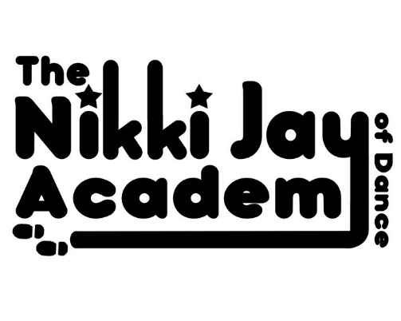
‘Everybody Dance Now!’ 2024
Show Permission Form
If you wish to Perform in/for your Child to Perform in our upcoming Show ‘Everybody Dance Now!’ please Print, Complete and Sign the Form below and hand it directly to Miss Nikki ASAP and Pay your Show Fee of £20 in to Miss Nikki’s Account. Thank you!
*Please Note: Without a Permission Form you will not be allowed to take part in the Show!
By Signing this Form you are Agreeing to the following:
*I would like to Perform in/like my Child to Perform in ‘Everybody Dance Now!’ 2024
*Name of Performer/s: ___________________________________________________
*I Agree to Pay the £20 Per Performer Show Fee
*I Agree to Attend All Classes between Now and the Show
(We reserve the right to remove pupils from routines/parts of routines if they have missed too many classes)
*I Agree to Attend the Rehearsal @ the Show Venue on Thursday 4th July from 4pm
(Timetable of 15min slots for each Routine to follow)
*I Agree to Arrive at the Show Venue
(Kings High School, Banbury Rd, Warwick, CV34 6YE)
No later than 12.30 and 4.30pm on the Performance Day
(Sunday 7th July for 1m & 5pm Shows lasting no longer than 1.5h)
*I give my Permission for Myself/My Child to be Photographed & Filmed & for any of that to be used for Advertising purposes after the Show
*I Agree to Pay to Hire/Buy our Costumes (Costs will be kept to a Minimum)
And to Return any Hired Costumes after the Show on Sunday 7th July or Pay to replace anything that is missing
*I Agree to leave my Child (Under 16) in the care of the DBS Checked Backstage Chaperones whilst the Show is running and take my Child away between Shows for fresh air and refreshments
*Cost wise you will need to pay for your Costume Fees and any Tickets you require. Show Hoodies, Photographs and a digital streaming service of the show will be available should you wish to purchase these.
This year we are, unfortunately, being forced to charge a small ‘Show Fee’, many schools now do this but I have managed to avoid it up up now. This will be just £20 per performer and will cover rehearsal costs and a Show T.Shirt which will be worn for the Show Finale. Please transfer this into my account when returning this form to me.

Signed ________________________________________(Under 16s need a Parent to Sign Please)
Printed__________________________________
Many Thanks for your support and cooperation! Miss Nikki X

