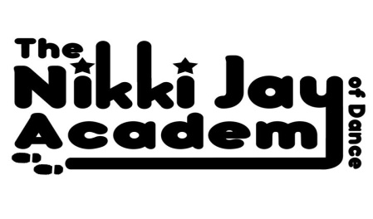
Class Fee Payment Policy

*All Pupils are entitled to 1 Free Trial per Subject they wish to try
*Fee’s are payable Termly and are Due in full by the 2nd Saturday of each Term
*Miss Nikki reserves the Right to Refuse to Teach you or your Child if the Fee Policy has not been adhered to
*Our Fee Policy can be found on our website
*Fee info and Dates for each Term can be found in the News section of our website and Reminders will appear on your Face Book News Feed if you ‘LIKE’ our Face Book Page!

*Fee’s must be Paid by Bank Transfer into Miss Nikki’s Account, Please see details below:
- Coventry Building Society Sort Code – 40-63-01
- Account No: 21560528
- Please use pupils name as Reference

*Please note you have agreed to our Fee Policy by Signing our contract/Registration Form when you Registered you/your Child @ The NJA

Many thanks, Miss Nikki (Principal AIDTA & AISTD)

07958 643005 office@njadance.co.uk www.njadance.co.uk
Please ‘LIKE’ our Facebook page for Reminders & Updates!

