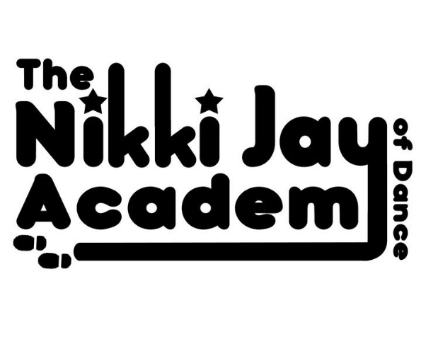
REGISTRATION FORM
PLEASE FILL IN AND RETURN TO MISS NIKKI

- Pupils Full Name:
- Pupils DOB:
- Address:

- Home Phone Number:
- Pupils Mobile Number:
- If under 18 – Mums Name & Mobile Number:
- If under 18 – Dads Name & Mobile Number:
- Other Emergency Name & Contact Number:
- Email Address:
- Special Needs if applicable:

- Parent Signature:

*Please note: By Signing above you are agreeing to the following Terms and Conditions and GDPR Info:
(More Details can be found on our Website: www.njadance.co.uk)

- Our Fee Policy
- Pupils NOT Taking Subjects at other Dance schools that we offer here
- Any Photo’s or Video footage taken of you/your child may be used as advertising
- Our Behaviour Policy
*THIS FORM WILL BE SCANNED AND KEPT ON MISS NIKKI’S PASSWORDED COMPUTER AND ALL PAPER COPIES DESTROYED
*GROUP EMAILS ARE SENT VIA MAILCHIMP – YOUR EMAIL ADDRESS DOES NOT APPEAR ON THE TOP FOR OTHERS TO SEE
*YOUR MOBILE NUMBER WILL BE KEPT IN MISS NIKKIS PASSCODED PHONES FOR CONTACT AND EMERGENCY PURPOSES ONLY
*YOUR PERSONAL INFO WILL NOT BE PASSED ON TO A THIRD PARTY APART FROM THE COUNCIL FOR SHOW LICENSES & IDTA FOR EXAMINATIONS
*IF THERE IS ANY INFO YOU DO NOT WISH TO SHARE PLEASE LEAVE IT OFF THIS FORM
*IF YOU LEAVE THE NJA YOUR INFO WILL BE DELETED ONCE YOUR BILL HAS BEEN SETTLED IN FULL
PRINCIPAL: NIKKI SHURVINTON AIDTA & AISTD 07958643005 office@njadance.co.uk www.njadance.co.uk

