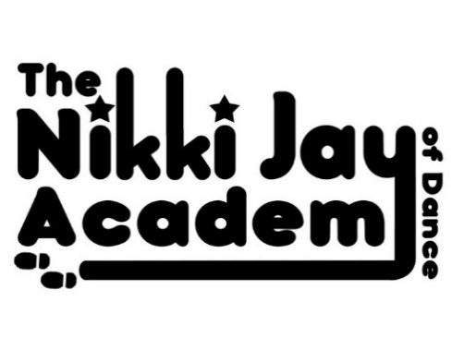
DATA COLLECTION AND GDPR INFO

The General Data Protection Regulation is a new EU Law that is effective from May 2018. In line with this regulation this document will help you be aware of and understand which data I collect, the reasons why, what it is used for and how I store it as well as the length of time I store it for.

- Lawful Reasons for Collecting Data:
I collect data so that I can communicate with parents of the Academy. This can be to share info about classes and events or so I can get hold of you while your child is in my care in case of an emergency. It is also important for me to collect any info on special needs and medical conditions as you are leaving your child in my/my teachers sole care.

- Use Data only for what it is collected for only:
I will not share your personal info with a third party except the council to organise show licenses if you choose to take part in Academy shows. The IDTA will also take your childs Name and DOB for Examinations.

- Only collect necessary Data:
I will collect the following Data when you first join the Academy and may ask for updates when needed.
- Name of Pupil
- DOB
- Address
- Both Parents Mobile Numbers
- Another Emergency Contact Name and Number
- Info on any special needs or medical conditions
- Email Address
- Your Permission to use your Childs Images/Video footage for Advertising purposes

- How Data is Stored:
The Registration Form you fill in with this info on when you first join the Academy will be scanned onto Miss Nikki’s (And Miss Laurens where Applicable) laptop which is Password Protected. Your Phone Numbers are kept on my/my teachers phones in case of emergency contact during classes, these are also passcoded. All Paper forms are then destroyed.

- Keeping Data for as long as necessary only:
I will hold this Data securely for as long as your child is a member of the Academy, once a parent withdraws their child from the Academy and when all Payments are Settled in Full, all Data will be destroyed.

This is also explained on the Registration Form you Sign upon Joining.
Please Sign Below to Agree that you have Read this and Fully Understand it and Return it to Miss Nikki ASAP:

-------------------------------------------------------------------------------------------------------

