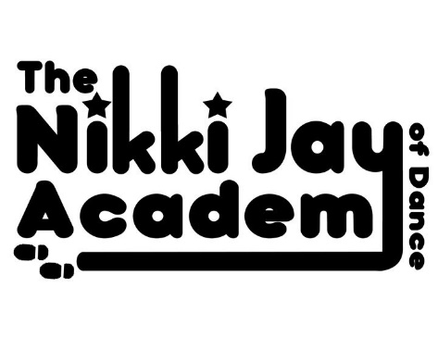
UNIFORM LIST

Once you have been with us for 6 Weeks, our Uniform becomes Compulsory,
Please see below what is expected to be warn for each Subject….

You can find all of this at our convenient Online Shop @ njd.mydancestore.co.uk, the Black & White Printed Uniform & the Dance Moms Uniform need to be ordered via Miss Nikki – Order Forms can be found on our Website & in your Welcome pack, please fill in, return to Miss Nikki & pay what is owed into her account.

SUBJECT | CLASS | REQUIRED UNIFORM | TO KEEP WARM | HOW TO ORDER
BALLET | Baby, Primary & Grade 1 | *1st Position ‘Milly’ Voile Skirted Cap Sleeve Leotard in Voilet  * Pink Leather Ballet Shoes  * Pink Ballet Socks | *1st Position Cotton/Poly 3/4 Cross Over Cardigan in Purple | @ Our Online Store:  njd.mydancestore.co.uk
BALLET | Grade 2 & up | *1st Position ‘Rachel’ double strap cross back Leotard in Black  * Pink Ballet Tights  * Split Sole Pink Leather Ballet Shoes | *1st Position Cotton/Poly 3/4 Cross Over Cardigan in Black | @ Our Online Store:  njd.mydancestore.co.uk
TAP | Prep, Primary & Grade 1 | *1st Position ‘Milly’ Voile Skirted Cap Sleeve Leotard in Voilet  *Bloch ‘Merry Jane’ Black Leather Tap Shoes  * Pink Ballet Socks | *1st Position Cotton/Poly 3/4 Cross Over Cardigan in Purple | @ Our Online Store:  njd.mydancestore.co.uk
TAP | Grade 2 & up | *1st Position ‘Rachel’ double strap cross back Leotard in Black  *NJA ‘Dance Moms’ Leggins  * Black Leather Jazz Style Tap Shoes  *Black Socks | Any NJA Hoody or T OR  NJA ‘Dance Moms’ Jacket | All @ Our Online Store:  njd.mydancestore.co.uk  Except NJA B&W Printed Uniform & NJA ‘Dance Moms’ Uniform – Order Forms for these can be found on our Website www.njadance.co.uk, please Print off, Fill in & Hand to Miss Nikki
STREET &  POP TOTS | All | *Any Combination of NJA B&W Printed Uniform & NJA ‘Dance Moms’ Uniform  *Bloch ‘Neo Flex’ Slip On Black Leather Jazz Shoes  *Black Socks | Any NJA Hoody OR  NJA ‘Dance Moms’ Jacket | @ Our Online Store:  njd.mydancestore.co.uk  Except NJA B&W Printed Uniform & NJA ‘Dance Moms’ Uniform – Order Forms for these can be found on our Website www.njadance.co.uk, please Print off, Fill in & Hand to Miss Nikki
G&T (INVITE ONLY) | N/A | *1st Position ‘Rachel’ double strap cross back Leotard in Black  *NJA ‘Dance Moms’ Leggins  *Bloch ‘Neo Flex’ Slip On Black Leather Jazz Shoes  *Black Socks | Any NJA Hoody OR  NJA ‘Dance Moms’ Jacket | All @ Our Online Store:  njd.mydancestore.co.uk  Except NJA B&W Printed Uniform & NJA ‘Dance Moms’ Uniform – Order Forms for these can be found on our Website www.njadance.co.uk, please Print off, Fill in & Hand to Miss Nikki

