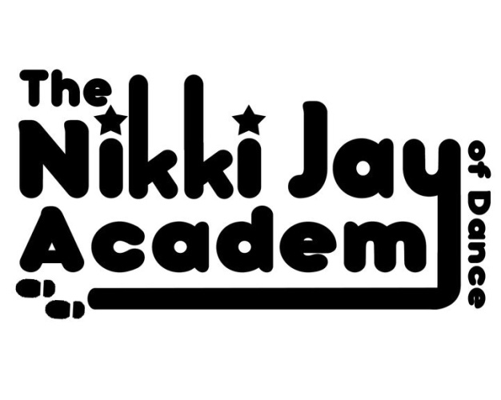
‘DANCE MOMS’ UNIFORM ORDER FORM
NAME: _____________________________

PLEASE TICK THE SIZE BOX ON THE ITEM YOU WOULD LIKE:
ITEM | 2YRS | 4YRS | 6YRS | 8YRS | 10YRS | 12YRS | SIZE 6 | SIZE 8 | SIZE 10 | SIZE 12 | SIZE 14 | SIZE 6
JACKET
LEGGINGS
CROP TOP
LEOTARD

PRICE LIST:
ITEM | 2YRS  4YRS  6YRS | 8YRS  10YRS  12YRS | ADULTS
JACKET | £35 | £40 | £46
LEGGINGS | £20 | £22 | £25
CROP TOP | £16 | £18 | £20
LEOTARD | £22 | £24 | £27
DEAL: FULL SET WITH CROP TOP | £66  SAVE £5 | £73  SAVE £7 | N/A
DEAL: FULL SET WITH LEOTARD | £72 SAVE £5 | £79  SAVE £7 | N/A

TOTAL OWED: £_______________
PLEASE PAY DIRECTLY INTO MISS NIKKI’S ACCOUNT & HAND FORM TO HER.
ORDERS MAY TAKE A FEW WEEKS TO ARRIVE AS ITS ALL HAND MADE TO ORDER.

