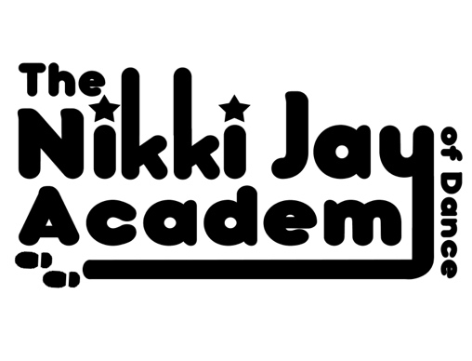

B&W PRINTED UNIFORM ORDER FORM

Please write size wanted in far right column plus name wanted on items if applicable -

Items we print names on have a * by them.

Please Pay straight into Miss Nikki’s Account upon ordering.

Pupils Name: _________________________________________________

ITEM | OFFICE USE ONLY | PRICE CHILD | PRICE ADULT | SIZES AVAILABLE | FILL IN SIZE WANTED & NAME IF APPLICABLE
NORMAL T.SHIRT | GD01B  SK201 | £9 | £13 | 3-4YRS  5-6YRS  7-8YRS  9-11YRS  12-14YRS  S(10) M(12) L(14) XL(16)
VEST TOP | SM016  SK016 | £11 | £14 | 4-6YRS  7-9YRS  10-12YRS  S(10) M(12) L(14) XL(16) 2XL(18)
OVER THE HEAD HOODY* | JH001  JH01J | £13 | £19 | 1/2YRS 24”  3/4YRS 26”  5/6YRS 28”  7/8YRS 30”  9/11YRS 32”  12/13YRS 34”  XS 34”  S 36”  M 40”  L 44”  XL 48”  2XL 52”
ZIP THROUGH HOODY* | JH50J  JH050 | £16 | £23 | 3/4YRS 26”  5/6YRS 28”  7/8YRS 30”  9/11YRS 32”  12/13YRS 34”  S 36”  M 40”  L 44”  XL 48”  2XL 52”
LEGGINS | SM064  SK064 | £11 | £13 | 3/4YRS 21”  5/6YRS 22”  7/8YRS 23”  9/10YRS 24.5”  11/12YRS 26”  XS 8  2 10  M 12  L 14  XL 16
VARSITY JACKET*  (BLACK & WHITE OR PURPLE & WHITE) | JH43J  JH043 | £22 | £26 | 3/4YRS 26”  5/6YRS 28”  7/8YRS 30”  9/11YRS 32”  12/13YRS 34”  XS 32”  S 34”  M 38”  L 42”  XL 36”  2XL 50”
BAG* | QD070 | £23 | £23 | N/A

Please Add up the Total Amount Owed: £______________

